**ASSIGNMENT 1 FRONT SHEET**

|  |  |  |  |
| --- | --- | --- | --- |
| **Qualification** | **BTEC Level 5 HND Diploma in Computing** | | |
| **Unit number and title** | Unit 14: Business Intelligence | | |
| **Submission date** | 10/4/2023 | **Date Received 1st submission** |  |
| **Re-submission Date** |  | **Date Received 2nd submission** |  |
| **Student Name** | Do Huu Duy | **Student ID** | GCC200018 |
| **Class** | GCC0903 | **Assessor name** | Nguyen Minh Khiem |
| **Student declaration**  I certify that the assignment submission is entirely my own work and I fully understand the consequences of plagiarism. I understand that making a false declaration is a form of malpractice. | | | |
|  |  | **Student’s signature** | huuduy |

**Grading grid**

|  |  |  |  |  |  |
| --- | --- | --- | --- | --- | --- |
| P1 | P2 | M1 | M2 | D1 | D2 |
|  |  |  |  |  |  |

|  |  |  |
| --- | --- | --- |
| **❒ Summative Feedback: ❒ Resubmission Feedback:** | | |
| **Grade:** | **Assessor Signature:** | **Date:** |
| **IV Signature:** | | |

**Assessment Brief**

|  |  |
| --- | --- |
| Student Name/ID Number |  |
| **Unit Number and Title** | **14: Business Intelligence** |
| Academic Year | 2019-2020 |
| Unit Tutor |  |
| **Assignment Number & Title** | **Assignment 1: Discover business process and BI technologies** |
| **Issue Date** |  |
| Submission Date |  |
| IV Name & Date |  |

|  |
| --- |
| **Submission Format** |
| The submission is in the form of a Microsoft® PowerPoint® style presentation to be presented to your colleagues. The presentation can include links to performance data with additional speaker notes and a bibliography using the Harvard referencing system. The presentation slides for the findings should be submitted with speaker notes as one copy. You are required to make effective use of headings, bullet points and subsections, as appropriate. Your research should be referenced using the Harvard referencing system. The recommended word limit is 500 words, including speaker notes, although you will not be penalised for exceeding the total word limit. |
| **Unit Learning Outcomes** |
| **LO1** Discuss business processes and the mechanisms used to support business decision-making.  **LO2** Compare the tools and technologies associated with business intelligence functionality |
| **Assignment Brief** |
| Your company is currently working in [Assumed Domain] for 2 years. For a new, young company, the competition in the market is very high. Therefore, the Board of Director has decided to apply Business Intelligence to improve the company business process by making better decisions.  The Board of Directors assigns a small group including you in Research & Development Department to study business intelligence to apply for the company in the coming years.  You need to research about business processes and decision support processes in the company and identify the types of data (unstructured, semi-structured or structured) generated by these processes with examples. You also need to research about current software used in the business process or decision support process and evaluate these usages (benefits and drawbacks).  Next you need to understand the types of support for decision-making at different levels (operational, tactical and strategic) within the company and study which business intelligence features can help on those types of support. Study the information systems or technologies (of BI) can be used in this case, compare and contrast them to conclude which should be used.  Your group needs to present the research results to the board in a presentation of 30 minutes. |

|  |  |  |
| --- | --- | --- |
| Learning Outcomes and Assessment Criteria | | |
| Pass | Merit | Distinction |
| **LO1** Discuss business processes and the mechanisms used to support business decision-making | | **D1** Evaluate the benefits and drawbacks of using application software as a mechanism for business processing. |
| **P1** Examine, using examples, the terms ‘Business Process’ and ‘Supporting Processes’. | **M1** Differentiate between unstructured and semi-structured data within an organisation. |
| **LO2** Compare the tools and technologies associated with business intelligence functionality | | D2 Compare and contrast a range of information systems and technologies that can be used to support organisations at operational, tactical and strategic levels. |
| P2 Compare the types of support available for business decision-making at varying levels within an organisation. | M2 Justify, with specific examples, the key features of business intelligence functionality. |

Table of Contents

I. Examine, using examples, the terms Business Process and Supporting Processes 6

1. Business Process 6

1.1. Definition Business Process 6

1.2. Business Process Phases 6

1.3. Benefits of Business Process 7

1.4. Example of Business Process 8

2. Supporting Process 9

2.1. Definition Supporting Process 9

2.2. Supporting Process Benefit 9

2.3. Example of Supporting Process 10

3. Describe datasets in project 10

4. Activity Diagram 13

4.1. Order creation process of Leather shop's staff 13

4.2. The manager's goods check-in process when import 14

4.3. Store owner's planning and statistical process 15

II. The types of support available for business decision-making at varying levels within an organization 16

1. Definition Business Decision-making 16

2. Business decision-making process steps 16

3. The types of support available for business decision-making at varying levels within an organisation 17

3.1. Operational Decision 17

3.2. Tactical decisions 19

3.3. Strategic decisions 20

3.4. Compare the types of support available for business decision-making at varying levels within an organization 22

III. Differentiate between unstructured and semi-structured data within an organisation 23

1. Unstructured Data 23

2. Semi-Structured Data 23

3. Different between unstructured and semi-structured data 23

IV. Justify, with specific examples, the key features of business intelligence functionality 24

V. Evaluate the benefits and drawbacks of using application software as a mechanism for business processing 26

VI. Compare and contrast a range of information systems and technologies that can be used to support organisations at operational, tactical and strategic levels 27

1. Transaction Processing System (TPS) 27

2. Decision Support System (DSS) 28

3. Management Information System (MIS) 28

References 29

List of Figures:

Figure 1. List table in Dataset 12

Figure 2. Tables in Dataset 12

Figure 3. Order creation process of Leather shop's staff 14

Figure 4. The manager's goods check-in process when import 15

Figure 5. Store owner's planning and statistical process 16

Figure 6. Characteristics of Operational Decision 18

List of Tables:

Table 1. Describe the tables in Dataset 12

Table 2. Structure table of order creation process of Leather shop's staff 15

Table 3. Structure table of the manager's goods check-in process when import 16

Table 4. Structure table of store owner's planning and statistical process 16

Table 5. Compare the types of support table 23

Table 6. Compare unstructured and semi-structured data table 24

Table 7. Advantages and disadvantages of Tableau tool 27

## I. Examine, using examples, the terms Business Process and Supporting Processes

## 1. Business Process

### 1.1. Definition Business Process

A business process is a technique you design to accomplish the intended company objectives. The objective can be to raise the caliber of outputs. Or it might simplythe goal is to merely raise the organization's revenue. To always achieve the required results, a sequence of connected tasks will cooperate. Many projects are being worked on simultaneously by an organization. Therefore, creating a uniform procedure lowers the likelihood of mistakes (Williams, 2021)

According to the (villanovau, 2022), A business process is fundamentally a set of repeated procedures used by a corporation to achieve a goal. Making progress toward your goals and enhancing the operations of your company depend on effective processes. A business process's goal is to assist your firm in achieving a certain objective. The use of procedures enables you to go forward with repeatable, dependable actions in your firm.

A good process meets three essential criteria:

* **Repeatability:** Every procedure needs to be made repeatable. An action plan, as opposed to a real process, is a procedure that you don't intend to repeat. It's the distinction between regular purchases and the acquisition of a new facility.
* **Transparency:** Processes must be trackable so that you can check on their success. An effective process includes data-tracking phases that let you compare performance and effectiveness over time.
* **Agility:** Processes that are set in stone don’t hold up in the real world. A process should be adaptable to multiple situations so small changes to the work environment don’t cause delays. Furthermore, a good process should be easy to update in case of more significant or permanent adjustments.

### 1.2. Business Process Phases

According to the (Williams, 2021), there are some the following phase of Business Process:

* **Define the goals:** The first stage in each project is to define the aim. What you anticipate from the process' execution must be stated in plain terms. It will aid in the beginning of the process development. When it comes to a business, you must be very specific about the measurements you'll use to gauge the success of the result.
* **Finding alternatives:** There is an alternative to every strategy you come up with. While creating business procedures, be careful to look into more options. Never deploy the initial draft without having backup strategies prepared. Each may be analyzed by considering the dangers involved, the length of time involved, and the cost-effectiveness.
* **Involve the stakeholders:** Any change that takes place inside the company needs stakeholder approval. Anything as significant as changing processes to make it better would undoubtedly need the stakeholders' consent. Set up a meeting and explain how these changes will help increase the organization’s revenue and value.
* **Run tests:** You must now assess the success of the new procedure after completing the final draft. Doing the procedure on a small scale is one approach to go about it. The majority of issues that might arise during real implementation usually surface during this stage. The required adjustments to the process document may then be made with ease.
* **Implement:** Now begins the crucial project phase, during which you put your prepared ideas into action. There will undoubtedly be some input from the staff throughout implementation. Educating them about the positive changes it brings to the business will ensure a smooth and effective adaptation.
* **Analyse:** You can always find methods to make your company better. The outcomes can fulfill your needs for the time being. Yet as time goes on, your views could shift. As a result, you should start evaluating the outcomes as soon as you apply these business procedures. That will give you a clearer notion of what to modify if something doesn't work out.

### 1.3. Benefits of Business Process

According to the (Williams, 2021), there are some the following benefits:

* **Risk reduction:** By outlining everything upfront, you can pinpoint the hazards that are most visible. Hence cutting down on the time needed to fix mistakes. Even very difficult to detect dangers that are revealed during the process’s test run.
* **Cost reduction:** You run tests on every process you ever create. Evaluation points out how you can optimize your business. It identifies unnecessary tasks. It also helps you find alternate ways of doing the tasks involved.
* **Agility:** As a business, you must be able to move through every process as quickly as possible. Changes to your process reduce the bottlenecks in the process. You can easily avoid duplication of tasks with the use of efficient business processes.
* **Boost productivity:** Your productivity will undoubtedly increase once everything you do follows a set procedure. Project approval, execution, and project approval all happen more quickly. You produce more quality products in less time.
* **Allows for new technology:** The business procedure should fluctuate often. Thus, enabling new technologies to improve your company. One of the finest things a company can do to maintain its existence is to adapt to the changing times.
* **Eliminates task isolation:** At a big company, a project is done in bits and pieces. Each component is created in a different department. Yet these activities are always related to one another. The final product will be of higher quality if it is kept that way. The project may go smoothly from one phase to the next when a procedure is laid out. It eliminates task separation, enhancing the efficiency of your company.
* **Improves compliance:** Standardized processes enable your employees to follow the right procedures. Standard procedures are all legally compliant. That makes every action your employees make safe and legal. It is one of the effective ways to reduce liability.
* **Improve transparency:** Well-informed employees are prone to make lesser errors than those who aren’t. So, a transparent workflow is the only way to keep your employees on the same track as your business goals.

### 1.4. Example of Business Process

A local insurance company is part of a regional chain with multiple offices. Its operations require multiple approvals from various offices. Since employees handle many tasks through email, many are failing to arrive or be on time. Manual coordination for every approval is tedious and time-consuming (Birt, 2022)

The home office developed a business process to simplify the approval process. Benefits from the process included:

* Easier coordination between offices
* Database creation for documentation
* Fewer missed or outdated emails
* Reduced manpower costs.
* Reduced copy machine and printing costs.

## 2. Supporting Process

### 2.1. Definition Supporting Process

According to the (businessprocessincubator, 2015), Supporting Process is processes support operation functions such as accounting, customer call center, technical support or safety training. Rather than influencing the process it takes to deliver products and services, these enable teams to do their jobs. Rather than customer value, internal employees often see the value in these. These are processes that coordinate the development and life cycle of the activities contained in the main processes, i.e., organizational and business processes. These processes can be undoubtedly cross processes, so that they contribute to the achievement of objectives between different areas of the project and / or company.

The actions in support processes are geared at reaching goals that aid in the support of other processes that carry out specific tasks. These goals can be used to:

* Specify the requirement for recording all data generated by process life cycle operations.
* Incorporate activities to identify, control, and statistical analysis processes together with version management.
* Specify the actions necessary to unbiasedly confirm that software products satisfy the required specifications and follow the laid-out plans.
* Define the software goods and services verification operations (for the acquirer, the supplier, or an independent entity).
* Establish activities (supplier, organization independent, or involving customers) for validating the software outcomes of the software project.
* Peer review should be carried out for both technical and administrative issues, and it should include an examination of the state of the produced items and the actions taken.
* Indicate the steps used to check for compliance with the plans, requirements, and contracts. Either of the two parties may employ this procedure, in which the audit party examines the output or operations of the other party (audited).
* Establish a procedure for analyzing and resolving issues (including conflicts), whatever their cause or type, that arise during the execution of the development, operation, maintenance, and other processes.

### 2.2. Supporting Process Benefit

According to the (ceopedia, 2023), there are some the following benefits:

* Better customer relations - Businesses may raise customer satisfaction and develop better connections by giving consumers access to support services and prompt help.
* Enhanced efficiency - Businesses may optimize their support activities utilizing automated processes and procedures, leading to speedier resolution times and fewer mistakes.
* Increased accountability - Businesses may make sure that all issues are handled promptly by recording customer enquiries and giving thorough records of support requests.
* Improved customer experience - Businesses can guarantee that consumers have access to the knowledge they need to make educated decisions by providing customers with an efficient Help procedure.
* Cost reductions - Businesses may cut costs by automating manual processes and procedures in the support process.

### 2.3. Example of Supporting Process

According to the (ceopedia, 2023), there are some the following examples:

* Help Desk: Customers receive technical assistance using this support procedure. This could entail resolving software and hardware problems, giving suggestions on how to use things, and responding to inquiries about goods and services.
* Customer Service: Customers may get help from this support system with their questions and issues. This could entail giving out product details, addressing customer grievances, assisting consumers with order placement, and offering technical assistance.
* Technical Support: Customers who are having technical problems can get support using this approach. This could entail offering guidance on how to utilize items and debugging hardware and software problems.

## 3. Describe datasets in project

Nowadays, leather fashion is one of the most sought after and sought after trends and since then many fashion designers and apparel manufacturing companies aim to produce a wide range of clothing made from leather. So, many leather businesses like BL were born and provide all kinds of leather to make costumes. BL is a small leather business that recently started selling its products on Amazon. Currently, it has around 40 registered SKUs in the Indian Market.

My dataset has some the following tables and is shown in the figure 1:

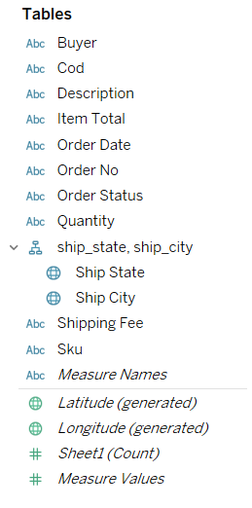

Figure 1. List table in Dataset

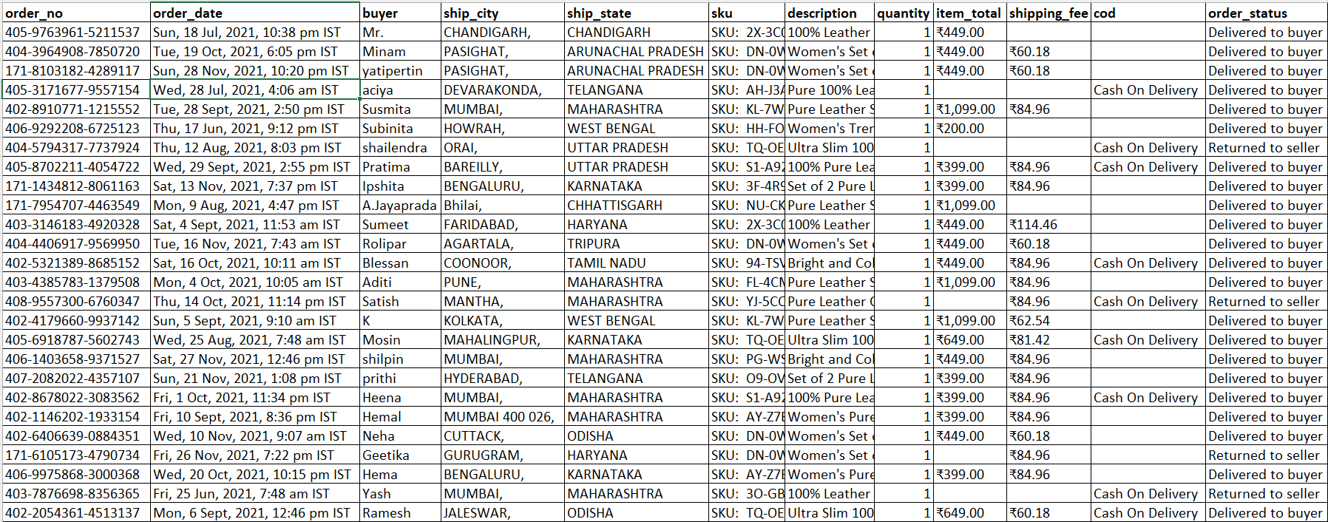

Figure 2. Tables in Dataset

Table 1. Describe the tables in Dataset

|  |  |  |  |
| --- | --- | --- | --- |
| No. | Table | Describe | Type of data |
| 1 | order_no | This table contain the id of order | String |
| 2 | order_date | This table contain the date that customer order | Date-time |
| 3 | buyer | This table contain name of buyer | String |
| 4 | ship_city | Delivery Address City | String |
| 5 | ship_state | Delivery Address State | String |
| 6 | sku | Identifier of a product | String |
| 7 | desciption | This table contain the description of product | String |
| 8 | quantity | Number of units ordered | integer |
| 9 | Item_total | Total amount paid by the buyer | float |
| 10 | shipping_fee | Charges borne by Boss Leathers to ship the item | float |
| 11 | cod | Mode of payment: Cash on delivery or not | String |
| 12 | order_status | Status of the order | String |

Link of dataset: <https://www.kaggle.com/datasets/pranalibose/amazon-seller-order-status-prediction>

## 4. Activity Diagram

### 4.1. Order creation process of Leather shop's staff

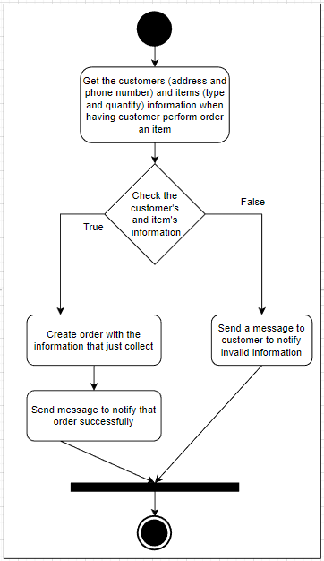

Figure 3. Order creation process of Leather shop's staff

In this process, the staff of Leather shop will get the customer's information and products information when having a customer order item, the staff will get this information such as customer's address, phone number and product's type, quantity that the customer require to check. If the customer's information and the product that customer order is valid the staff will create the order and notify to customer that order successed, but if the customer's information or product that customer want to order is invalid such as the product's quantity that customer want to order is more than the product's quantity in the stock or the product's type is not valid, the staff will notify to the customer that the information is invalid and order is not success.

Table 2. Structure table of order creation process of Leather shop's staff

|  |  |  |
| --- | --- | --- |
| **Unstructured** | **Semi-structured** | **Structured** |
| - Image of product | - Notify order success and not success | - Customer’s information  - Product’s information |

### 4.2. The manager's goods check-in process when import

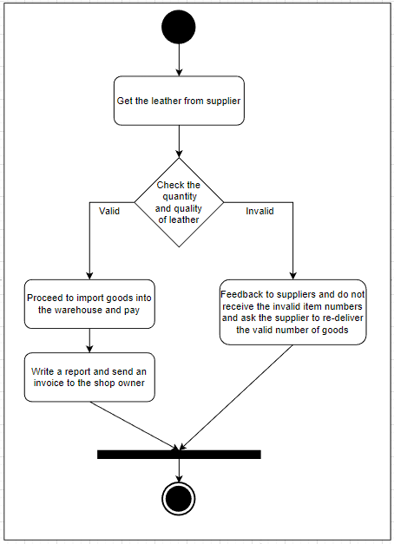

Figure 4. The manager's goods check-in process when import

In this process, the manager of the Leather shop will get all of the goods from the supplier delivery and check whether the product's quality and the number of products is valid or not. If it's not valid the manager will return to the supplier and send feedback to the supplier about the goods's status, then require them re-deliver that is invalid, but if the goods are valid the manager will import goods into the stock and paymentfor supplier, then the manager will write report and send the invoice to the shop's owner.

Table 3. Structure table of the manager's goods check-in process when import

|  |  |  |
| --- | --- | --- |
| **unstructured** | **semi-structured** | **structured** |
| - Image of product | - Import goods successfully  - Import goods failly | - Goods’s information  - Supplier’s information |

### 4.3. Store owner's planning and statistical process

Figure 5. Store owner's planning and statistical process

This diagram describes the statistical process of the owner. The owner will perform statistics and check the revenue of the store in each quarter of the year. If the revenue is good the owner can make plan to develop and expand the store, but if the revenue is not good the owner can make plan to remendial and improve.

Table 4. Structure table of store owner's planning and statistical process

|  |  |  |
| --- | --- | --- |
| **unstructured** | **semi-structured** | **structured** |
| - Image of product | - Statistic is good  - Statistic is not good | - Product’s information  - Revenue’s information |

# II. The types of support available for business decision-making at varying levels within an organization

## 1. Definition Business Decision-making

According to the (lucidchart, 2023), The business decision-making process is a sequential procedure that enables experts to resolve issues by assessing the facts, analyzing the options, and selecting a course of action from there. At the conclusion of this clearly defined procedure, there is also a chance to assess if the choice was the appropriate one.

## 2. Business decision-making process steps

According to the (lucidchart, 2023), there are 7 steps to perform business decision-making:

* **Identify the decision:** To make a decision, you must first identify the problem you need to solve or the question you need to answer. Clearly define your decision.
* **Gather relevant information:** It's time to acquire the facts pertinent to that decision once you've decided what to do. Do an internal review to see where your company has excelled and where it has fallen short in relation to your choice. Also, look for information from outside sources, such as market research, studies, and, in certain situations, expert opinion from paid consultants.
* **Identify the alternatives:** Determine potential solutions to your problem now that you have the necessary facts at your disposal. While attempting to achieve a goal, there are typically several options to take into account. For instance, if your business wants to increase social media engagement, your options can be to adjust your organic social media strategy, use sponsored social marketing, or a mix of the two.
* **Weigh the evidence:** Consider the evidence in favor of or against each possibility when you have selected several. Look at what businesses in the past did to achieve success in these areas, and carefully consider your organization's own successes and failures. For each of your possibilities, consider any potential risks and assess the potential benefits.
* **Choose among alternatives:** This is the stage of the decision-making process where the choice is really made. Ideally, you've determined and clarified the choice that must be taken, acquired the necessary data, and created and thought through the possible routes. You should be ready to make a decision.
* **Take action:** After you've made a decision, follow through with it! Create a strategy to make your choice real and doable. After creating a project plan for your choice, assign responsibilities to your team.
* **Review your decision:** Take an honest look back at your choice after the time period you specified in step one of the decision-making processes. Did you come up with a solution? Did you respond to the query? Did you achieve your objectives?

## 3. The types of support available for business decision-making at varying levels within an organisation

### 3.1. Operational Decision

Operational decisions are quick judgments that are often made once a week, once a day, or once an hour. To maximize product flow in biomass-based production chains, they are primarily concerned with operational details, daily resource allocation, inventory control, and delivery routing. Operational choices may be modified and changed often as a result of the shifting internal and external conditions of supply chains and associated operations (quixy, 2023)

According to the (quixy, 2023), Operational decisions consist of three steps:

* Input Data
* Decision Logic
* Output or action

According to the (quixy, 2023), there are five characteristics of operational decision:

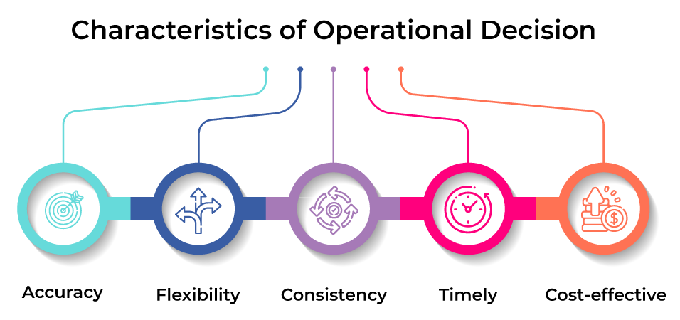

Figure 6. Characteristics of Operational Decision

* Accuracy: Effective operational choices use data quickly and efficiently to take the required action, acting like knowledgeable workers with the relevant reports and analysis. They use this information to gain insight into the future rather than merely being aware of the past, and they use that understanding to conduct more properly. They target their consumers utilizing data about them through micro-segmentation and intensive customization.
* Flexibility: To reflect new opportunities, organizations, and threats, operational decisions must be made rapidly; else, their value would swiftly diminish. No modern corporate structure can stand long stretches of stagnation. That is not conceivable in the current competitive, economic, and regulatory environment. Businesses that automate their processes and transactions usually find that how quickly they can update their information systems has a significant impact on how quickly they respond to change. To decrease lost opportunity costs and improve overall business agility, operational choices must be straightforward and easy to modify quickly and efficiently.
* Consistency: Throughout the multiple channels you use to do business, such as the web, mobile devices, interactive voice response systems, and kiosks, your operational choices must be consistent over time and location. They provide you with the ability to act differently when you want to, like providing a discount online to encourage the use of a less expensive channel, but they also ensure that you don't act differently mistakenly. Both the individuals who directly work for you and the third parties and agents who represent you are supported by these systems. By adhering to your company's policies about laws, regulations, and social norms everywhere it conducts business, they make sure you remain out of trouble. They consistently offer your employees first-rate experience.
* Timely: You must take action as soon as you can. As they say online, your competitor is just three clicks away. Your employees are becoming impatient and have short attention spans. Your supply and demand chain management systems must respond quickly and shrewdly as they become increasingly real-time. Because there are fewer employees handling more clients, partners, and suppliers, you must shorten wait times for these employees. You must act right now and make a decision.
* Cost-effective: Above all, operational decisions must be frugal. Despite major reductions and gains in efficiency over the past few years, cost saving is still essential. Good operational decisions minimize unnecessary activities and expensive reporting. They decrease fraud and stay out of trouble. They make it possible for your staff to work more productively and manage their time well. They make sure you do as many tasks accurately the first time as possible and prevent expensive "do-overs." They reduce friction, which slows down business and increases costs.

**Example of Operational decisions:**

* Monthly and daily forecasts to determine the demand from end users.
* Determining the deadline for satisfying demand and analysing the variances between lead time and deadline.
* Scheduling and planning for daily and weekly production.
* Assigning a cargo of biomass products or sources to a certain method of transportation and vehicle.
* Routes and timetables for daily and weekly deliveries, fleet management.
* Keeping track of supply shortfalls and backlogs, planning additional daily and weekly operations to address the shortages.
* Control and replenishment of inventories every day and every week.
* Scheduling the work and keeping shifts.

### 3.2. Tactical decisions

According to the (Chand, 2023), These choices have to do with carrying out strategic choices. They are focused on creating divisional strategies, organizing processes, building channels for distribution, and acquiring resources including personnel, materials, and cash. The intermediate level of management is where these choices are made.

According to the (ceopedia, 2023), there are some the following advantages and disadvantages ò Tactical decisions:

**Advantages of Tactical decisions:**

* They make it possible for companies to swiftly adapt to changes in the marketplace or environment. In a market that is changing quickly, organizations may stay competitive by making more nimble tactical decisions.
* Since they are more concentrated on short-term goals, they are simpler to implement. Decisions made at the tactical level may be promptly put into action and do not call for lengthy commitments.
* Since they concentrate on short-term goals, they are more cost-effective. A company can save money by avoiding expensive long-term investments thanks to tactical actions.
* They provide you with the flexibility you need to rapidly alter tactics when you need to. Because tactical choices are more adaptable, organizations may swiftly alter their plans as required.

**Disadvantages of Tactical decisions:**

* Information deficiency: Tactical choices are frequently made with incomplete knowledge and may not account for all possible external variables and influences.
* A short-term focus: Tactical choices are frequently made as short-term fixes and may not be appropriate for long-term goals.
* Resources are few: Making tactical judgments when resources are scarce may limit the range of available possibilities.
* Unexpected effects: Tactical choices may have unanticipated effects that may be challenging to cope with afterwards.
* Lack of adaptability: Tactical choices may be rigid and unable to change in response to new information.

**Example of Tactical decisions:**

According to the (ceopedia, 2023), Tactical decision have some the following examples:

* Deciding which markets to target and how to penetrate them.
* Setting pricing and promotional strategies for products and services.
* Allocating resources (people, money, and time) to various projects.
* Developing new product or service offerings.
* Establishing performance objectives and standards.
* Establishing operational processes and procedures.
* Deciding which suppliers and vendors to use.
* Deciding which new technologies to adopt.
* Choosing which new initiatives to pursue and which to drop.
* Deciding how to respond to competitive pressures.
* Establishing customer service policies.
* Making changes to organizational structure.

### 3.3. Strategic decisions

Strategic decisions of action have a significant impact on the entire or a significant portion of a company operation. They immediately assist in achieving the enterprise's shared objectives. They affect the company enterprise over the long haul. These could entail significant changes from past techniques and processes. Strategic decisions are typically unstructured, so a manager must use his or her business judgment, assessment, and intuition to define the issue. These choices are based on a limited understanding of the unpredictable and changing environmental conditions. These selections are made at the top echelons of management (Chand, 2023)

**Advantages of Strategic decision:**

According to the (indeed, 2022), Strategic decision have some the following advantages:

* **Structure:** You may use strategic decision-making to provide structure for your evaluation procedure. Having a framework may assist in reducing the stress brought on by complicated problems, and depending on how your organization is set up, it can also be a useful tool for encouraging teamwork and collaboration. For all important company choices, consider employing a strategic decision-making framework.
* **Predictability:** It could be simpler to predict the results of some business actions if you connect your shorter-term choices with the longer-term effects. When attempting to predict the development and expansion of an organization, this may be quite useful. Think about including strategic decision-making in your organization's development forecast.
* **Collaboration:** When people collaborate, strategic decision-making is often more successful. A team working together to reach a conclusion could come up with more creative alternatives and notice more subtleties than one individual acting alone. The collaborative aspect of strategic decision-making may also aid in fostering an innovative and cooperative workplace culture. Adding strategic decision-making to your hiring and employee retention efforts is another option you might want to think about.
* **Flexibility:** Throughout time, your organization's longer-term vision and goal may change and advance, and strategic decision-making may provide the essential flexibility. By coordinating your shorter-term, more manageable goals and decisions with the long-term corporate vision, you may utilize it to adapt to changing goals. As a result, it may be simpler to change your short-term choices to support your long-term goals.

**Disadvantages of Strategic decision:**

According to the (Simplilearn, 2023), Strategic decision have some the following disadvantages:

* **Lack of readiness for an unforeseen future:** Strategic management calls for an organization to project the future in order to create plans. When events don't go as planned, the chosen approach may be rendered useless.
* **Expensive alternative:** Many non-profit organizations cannot afford to employ an outside expert for efficient plan creation. Even for businesses that can afford it, it's crucial to make sure that the strategic management process is implemented in a way that is consistent with the goals of the company and has the right controls to enable cost-benefit analysis.
* **Limits flexibility:** Often times, businesses use overly formal strategic management procedures. Innovativeness and inventiveness are lacking in the current procedures. These may limit an organization's capability for creative problem-solving and hinder its ability to adapt and evolve.
* **Long-term benefit vs. quick results:** Because strategic management is intended to provide long-term advantages, it may not first appear profitable. One must choose an alternative course of action for urgent crisis management. Companies are frequently advised to solve current issues before devoting resources to strategic management.

**Example of Strategic decisions:**

The goal of a dog food business is to market the healthiest dog food. The firm director observes that despite the fact that the two types of dog food have comparable nutritional values, buyers choose high-quality freshly made food. The director gave the strategy that changes the company's product line to concentrate on premium, freshly made dog food in order to steer the company's future to meet the changing tastes of its clients. Dog owners will pay more for freshly made food, therefore even if the items have a shorter shelf life, the profit margin is enhanced (Team, 2022)

### 3.4. Compare the types of support available for business decision-making at varying levels within an organization

According to (Greenwich, 2023), Difference between the types of support available for business decision-making at varying levels within an organization

Table 5. Compare the types of support table

|  |  |  |  |
| --- | --- | --- | --- |
|  | Types of Control | | |
| Types of Decisions | **Operational Control** | **Managerial Control** | **Strategic Control** |
| Structured | Accounts receivable Accounts payable Order entry | Budget analysis Short-term forecasting Personnel reports Make-or-buy. | Financial management Investment portfolio Warehouse location Distribution systems |
| Semi-Structured | Production scheduling Inventory control | Credit evaluation Budget preparation Plant layout Project scheduling Reward system design Inventory categorization | Building a new plant Mergers & acquisitions new product planning Compensation planning Quality assurance HR policies Inventory planning |
| Unstructured | Buying software Approving loans Operating a help desk Selecting a cover for a magazine | Negotiating Recruiting an executive Buying hardware Lobbying | R&D planning new tech development social responsibility planning |

# III. Differentiate between unstructured and semi-structured data within an organisation

## 1. Unstructured Data

Unstructured data is data that is not established in terms of organization or lacks a preset data model, making it a poor fit for a common relational database. Unstructured data may therefore be stored and managed on different platforms, and companies use it in a range of business intelligence and analytics applications. Unstructured data is becoming more common in IT systems. Example: Word, PDF, Text, Media logs (geeksforgeeks, 2023)

## 2. Semi-Structured Data

Information that is not stored in a relational database but has certain organizational characteristics that make it easier to examine is considered semi-structured data. Although some types of semi-structured data may be particularly difficult to store in relational databases, semi-structured data exists to save space. Example: XML data (geeksforgeeks, 2023)

## 3. Different between unstructured and semi-structured data

According to the (geeksforgeeks, 2023), the table is the compare table about the Different between unstructured and semi-structured data.

Table 6. Compare unstructured and semi-structured data table

|  |  |  |
| --- | --- | --- |
| Properties | Semi-structured data | Unstructured data |
| Technology | Its foundation is XML/RDF (Resource Description Framework). | Based on binary and character data. |
| Transaction management | Transactions are modified from immature DBMSs. | absence of concurrency and transaction management |
| Version management | It is possible to version across tuples or graphs. | Versioned in its entirety |
| Flexibility | Compared to organized data, it is more flexible, while unstructured data is less flexible. | There is no schema, and it is more flexible. |
| Scalability | Scaling is less complicated than with structured data. | It can scale up more. |
| Robustness | Modern technology, not widely used |  |
| Query performance | It's possible to do queries on anonymous nodes. | Only text-based queries are supported. |

# IV. Justify, with specific examples, the key features of business intelligence functionality

**Featrure of Business Intelligence:**

According to the (atatus, 2021), Business Intelligence have some the following features:

* Reporting: Business intelligence reporting software that compiles data from one or more data sources and presents it in an easy-to-read manner can help business users stay informed and obtain answers to queries presented at regular intervals. Ad hoc reports may be produced for the web, print, or mobile devices, and sophisticated, interactive dashboards with thousands of users can be produced.

**Example: According to (Memon, 2021), KPIs-based scorecard report example:**

According to Eva Lerma of My Travel Tripod, "A scorecard is a sort of BI report that offers a complete summary of different KPIs of an organization." Green, yellow, and red status symbols and trend lines are used to show how each KPI measure is developing in relation to business aims and objectives. The KPIs are given in a tabular format. These status symbols serve as rapid performance indicators, letting readers know at a glance how each KPI is performing. This report is helpful since it "shows companies their overall success toward several goals," as Lerma emphasizes. This makes it easier for them to identify and improve the metrics that require it. It goes without saying that managers, business owners, employees, and everyone else can make better judgments the better and easier it is to evaluate data. To this aim, Lerma advises you to generate this kind of business intelligence report using data analytics tools like Google Analytics. Lerma claims that the technologies aid in the conversion of data into useful information. This report is helpful since it "shows companies their overall success toward several goals," as Lerma emphasizes. This makes it easier for them to identify and improve the metrics that require it. It goes without saying that managers, business owners, employees, and everyone else can make better judgments the better and easier it is to evaluate data. To this aim, Lerma advises you to generate this kind of business intelligence report using data analytics tools like Google Analytics. Lerma claims that the technologies aid in the conversion of data into useful information. These technologies can handle enormous quantities of data and display it in a variety of ways, including pie charts, bar graphs, and pictograms, according to Lerma. According to the requirements of the business, business users can select the formats of their choice.

* Analysis: With data analysis tools created to analyze, display, and manipulate any type of data to aid improved decision-making, users may see trends, spot issues, and produce insights. To examine data from any source, they can employ complex relational OLAP or in-memory analysis.

Example: According to (Durcevic, 2019), business analytics examples are focused on discovering new business insights that can ultimately help streamline commercial processes, thereby improving productivity and boosting the bottom line. A forward-thinking online restaurant wanted to be able to improve sales reports and marketing activities in a time-, money-, and labor-saving manner while acquiring a deeper understanding of the client life cycles. The company was able to streamline its marketing and sales activities, make better, quicker decisions based on real-time information, and uncover new insights that have served to improve its level of customer experience, leading to an increase in brand loyalty by gaining self-service access to real-time analytical information.The burgeoning online food behemoth is now able to track all important company processes using tailored KPIs thanks to the deployment of a real-time dashboard. Also, the organization is now better equipped to respond to difficulties as they arise rather than waiting weeks or even months to do so thanks to the new business analytics platform. The data was presented on a single screen and made easy to engage with thanks to sales figures and charts.

* Dashboard: Using dashboards that combine data and graphical indications and provide at-a-glance summaries, users may assess the condition of the business, track key performance indicators (KPIs), get insight into the historical and real-time context, and respond quicker. Software developers boost the value and competitiveness of their products by including these dashboards into executive and knowledge worker applications.

**Example: According to (Tableau, 2023), Healthcare data:**

In this visualization (viz) by Bridget Cogley, examine patient demographics and trends by department. This visualization utilizes Tableau's clustering tool to glean insights from hospital data and distinguish between frequent short-stay patients and those who require longer stays.

* Data Integration: A data mart or warehouse can be constructed using data integration software, which extracts, transforms, and loads (ETL) data from several sources for reporting and analysis. Many different relational or non-relational data sources may be combined and made easily accessible using data virtualization technologies.

Example: According to (Stitchdata, 2021), an illustration of a business is See Food, Inc. (SFI). The smartphone app developed by SFI allows users to snap images of various objects and determine whether or not they are hot dogs. SFI employs several tools to do business, including:

* Facebook Ads and Google Ads in order to acquire new users
* Google Analytics to track events on its website and in its mobile app
* MySQL database to store user information and image metadata (e.g. hot dog or not hot dog)
* Marketo to send marketing email and nurture leads
* Zendesk to perform customer support
* Netsuite for accounting and financial tracking

There is a silo of data on SFI's activities in each of those apps. All of the information must be gathered in one location in order for SFI to have a complete picture of the company. It is called data integration.

# V. Evaluate the benefits and drawbacks of using application software as a mechanism for business processing

In this project, I used the Tableau tool to support me in the business process. With using Tableau tool have some the following advantages and disadvantages by (KnowledgeHut, 2022)

Table 7. Advantages and disadvantages of Tableau tool

|  |  |  |
| --- | --- | --- |
| Tableau | Advantages | Disadvantages |
| Superior Performance | Poor Versioning |
| Mobile-Friendly | No automatic refreshing of reports |
| Fantastic mobile support | Requires manual effort |
| Easy to upgrade | Not a full-fledged remedy |
| Low cost | Without version control |
| Exceptional Customer Service | Need understanding of SQL |
| Effortless Usage |  |

I chose the Tableau tool to use in my project and in the using process and when I use Tableau tool, I feel this tool has some of the following benefits. Firstly, it is free. Using a free tool is convenient for students like me. Secondly, it is easy to use and there are features that support me in three business processes that help me statistic easily and quickly. Last, with Tableau tool it can draw diagrams when I perform statistical, this helps me have a visual look about the data. However, when using Tableau tool, they bring some weakness. Firstly, it will be complicated for new users. In my view, I feel it's easy to use but I also get some difficult when using them for the first time. Secondly, to use them, we need to have knowledge about SQL such as we must know to query the data. Conclusion, these are the benefits and weakness that I get when using Tableau tool in my project.

Apart from Tableau tool, I also will suggest a tool that can be used to support business process, this is PlantUML tool we can use them to draw three of business process in my project. With PlantUML, they have some the following pros and cons by (slant, 2020):

**Pros:**

* Many integrations
* Easy create diagrams from text
* Free/libre/open source (GPL)
* Has online editors
* sphinx-contrib extension for embedding into docs

**Cons:**

* For new users, the "plantUML-language" is a little weird and challenging to understand.
* Due to it being mostly a one-man effort, development has been slow.
* Not maintained

# VI. Compare and contrast a range of information systems and technologies that can be used to support organisations at operational, tactical and strategic levels

## 1. Transaction Processing System (TPS)

According to the (Martin, 2023), Organizations use systems for processing transactions to monitor everyday company operations. They are used by users at the operational management level. The main objective of a transaction processing system is to offer solutions to frequent questions.

By monitoring regular business activities, the TPS system provides rapid responses to the aforementioned questions: Operational managers rely on their regular, thorough decisions on meticulous data produced by the transaction processing system.

**Examples of transaction processing systems include:**

• Point of Sale Systems: records daily sales

• Payroll systems: processing employee’s salaries, loans management, etc.

## 2. Decision Support System (DSS)

To make difficult judgments, senior management employs decision support technologies. Decision support systems receive input from both internal (such as systems for transaction processing and management information systems) and external systems.

The main objective of decision support systems is to present special, dynamic problems with solutions.

In order to provide solutions, decision support systems employ sophisticated mathematical models and statistical techniques (such as probability, predictive modeling, etc.) (Martin, 2023)

**Examples of decision support systems include:**

• Financial planning systems: It allows managers to assess alternate strategies for reaching objectives. Finding the best method to accomplish the goal is the goal.

• Bank loan management systems: It is employed to assess the borrower's creditworthiness and gauge the possibility that the loan will be repaid.

## 3. Management Information System (MIS)

Management information systems (MIS) are used by tactical managers to monitor the organization's current performance condition. The output of a transaction processing system serves as the input for a management information system.

By frequently analyzing the data with algorithms that aggregate, compare, and summarize the results, the tactical managers utilize the reports that the MIS system provides to monitor, control, and anticipate future performance.

The tactical manager must make a semi-structured choice. The tactical managers estimate how much inventory or goods should be ordered for the second quarter based on the first quarter's sales using their knowledge and the data given by MIS systems (Martin, 2023)

**Examples of management information systems include:**

• Sales management systems: they receive data from the POS system.

• Budgeting systems: presents a summary of the organization's long- and short-term financial spending.

• Human resource management system: general employee satisfaction, staff turnover, etc.

# References

atatus, 2021. *atatus.com.* [Online]   
Available at: https://www.atatus.com/glossary/business-intelligence/

Birt, J., 2022. *indeed.com.* [Online]   
Available at: https://www.indeed.com/career-advice/career-development/business-processes

businessprocessincubator, 2015. *businessprocessincubator.com.* [Online]   
Available at: https://www.businessprocessincubator.com/content/what-are-support-processes/

ceopedia, 2023. *ceopedia.org.* [Online]   
Available at: https://ceopedia.org/index.php/Support_process

ceopedia, 2023. *ceopedia.org.* [Online]   
Available at: https://ceopedia.org/index.php/Tactical_decision

Chand, S., 2023. *yourarticlelibrary.com.* [Online]   
Available at: https://www.yourarticlelibrary.com/information-technology/decisions-making-strategic-tactical-and-operational-decisions-business-management/10271

geeksforgeeks, 2023. *geeksforgeeks.org.* [Online]   
Available at: https://www.geeksforgeeks.org/difference-between-structured-semi-structured-and-unstructured-data/

Greenwich, M., 2023. *flm.greenwich.* [Online]   
Available at: https://flm.greenwich.edu.vn/gui/role/guest/ListScheduleSyllabus?subjectCode=4GAWtdT5vCIzcRpXEuffdA==&SessionNo=XbIGy1f4uwm8RzSGtT1cyA==

indeed, 2022. *indeed.* [Online]   
Available at: https://uk.indeed.com/career-advice/career-development/strategic-decision-making-examples#:~:text=Strategic%20decision%2Dmaking%20refers%20to,contribute%20to%20its%20overall%20mission.

KnowledgeHut, 2022. *knowledgehut.com.* [Online]   
Available at: https://www.knowledgehut.com/blog/business-intelligence-and-visualization/tableau-advantages-disadvantages

lucidchart, 2023. *lucidchart.com.* [Online]   
Available at: https://www.lucidchart.com/blog/decision-making-process-steps#:~:text=The%20business%20decision%2Dmaking%20process%20is%20a%20step%2Dby%2D,decision%20was%20the%20right%20one.

Martin, M., 2023. *guru99.com.* [Online]   
Available at: https://www.guru99.com/mis-types-information-system.html

Memon, M., 2021. *databox.* [Online]   
Available at: https://databox.com/business-intelligence-report-examples#3

quixy, 2023. *quixy.* [Online]   
Available at: https://quixy.com/blog/what-are-operational-decisions/

Simplilearn, 2023. *simplilearn.com.* [Online]   
Available at: https://www.simplilearn.com/benefits-of-strategic-decision-making-article

slant, 2020. *slant.co.* [Online]   
Available at: https://www.slant.co/options/13471/~plantuml-review

Team, I. E., 2022. *uk.indeed.com.* [Online]   
Available at: https://uk.indeed.com/career-advice/career-development/strategic-decision-making-examples

villanovau, 2022. *villanovau.com.* [Online]   
Available at: https://www.villanovau.com/resources/bpm/what-is-a-business-process/

Williams, S., 2021. *peppybiz.* [Online]   
Available at: https://www.peppybiz.com/blog/business-processes